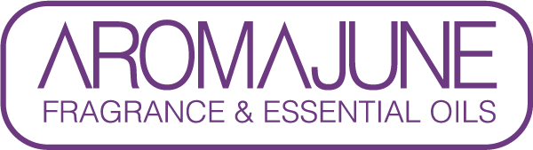

DATE : {{DATE}}
TO : {{CUSTOMER}}
SUBJCET : METHYL SALICYLATE CERTIFICATE
PRODUCT NAME : {{PRODUCT}}

AROMAJUNE hereby confirms that, to the best of our knowledge, the above-mentioned product contains:
- Methyl salicylate(CAS NO. 119-36-8) 00.00%

